This is **Problem 7.2** of your textbook.

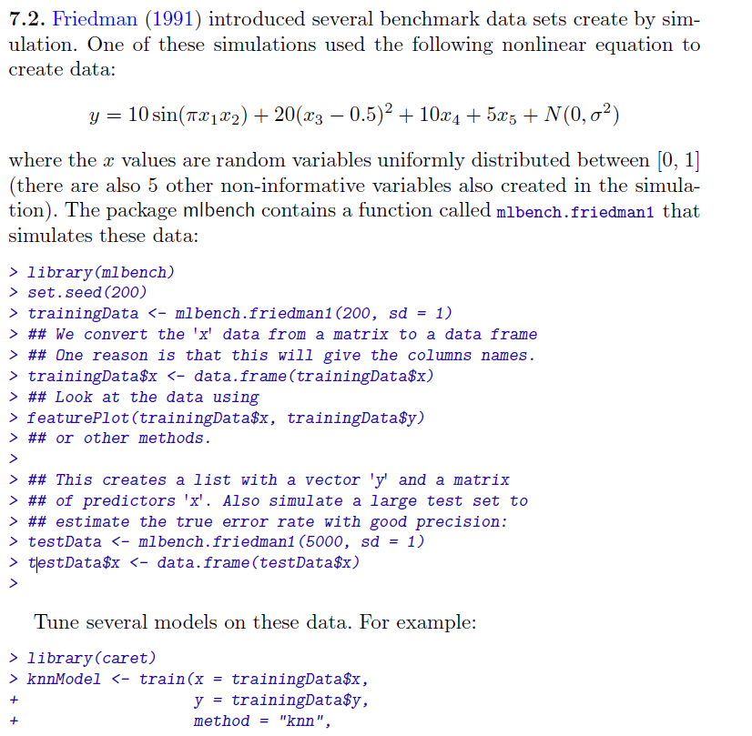

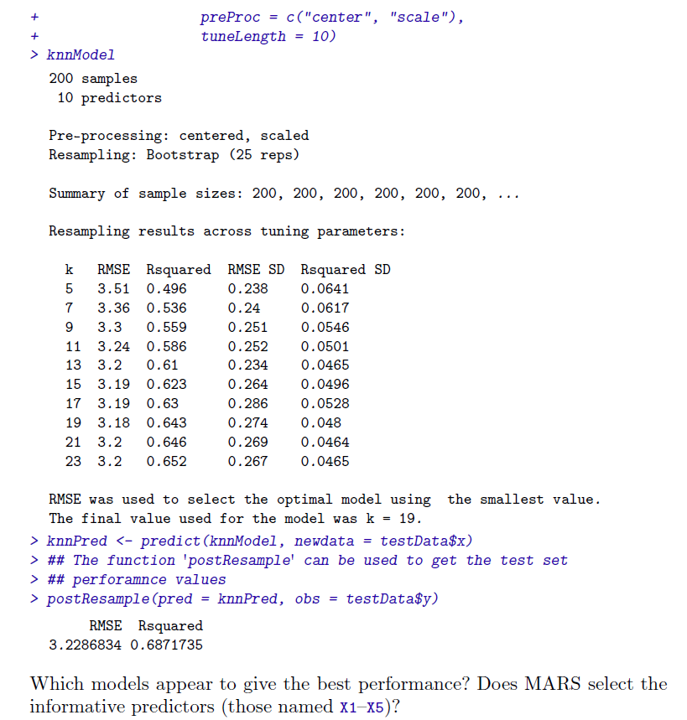

Note: For this exercise, you need to consider at least three of the following models: kNN, MARS, Neural Network, and Support vector machines with a specified kernel.